GRADE 7 ACCELERATED · UNIT 2 · LESSON 1  Square Values  Worksheet 7A.02.01 | Name_________________________  Date__________________________  Period________________________

1. Complete the table. Each area is the side length multiplied by itself.
Side s | 1 | 2 | 3 | 4 | 5 | 6 | 7 | 8 | 9 | 10
Area s²

2. Select ALL of the numbers below that are perfect squares.
☐ | 1 | ☐ | 8
☐ | 16 | ☐ | 20
☐ | 36 | ☐ | 45
☐ | 49 | ☐ | 60
☐ | 64 | ☐ | 100

For questions 3 through 5, find the area of a square with the side length given.
3. Side length 12 units

4. Side length  cm

5. Side length 0.7 units

For questions 6 through 8, find the length of one side of a square with the area given.
6. Area 81 square inches

7. Area 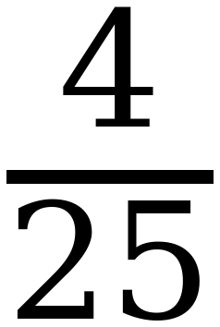 square centimeters

8. Area 2.25 square units

Questions 9 and 10 use the equation y = x².
9. Complete the table of values. Then plot the seven points on the grid.
x | Substitute into y = x² | Coordinates (x, y)
−3
−2
−1
0
1
2
3

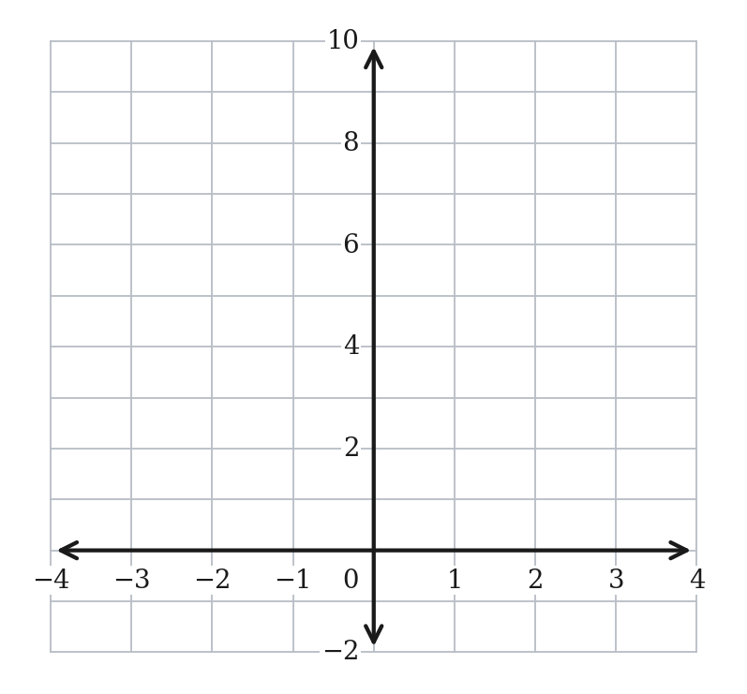
10. Will the graph of y = x² ever go below the x-axis? Explain why or why not.

11. Can a square have an area of 8 square units? If it can, name the two whole numbers its side length falls between. Explain how you know.

